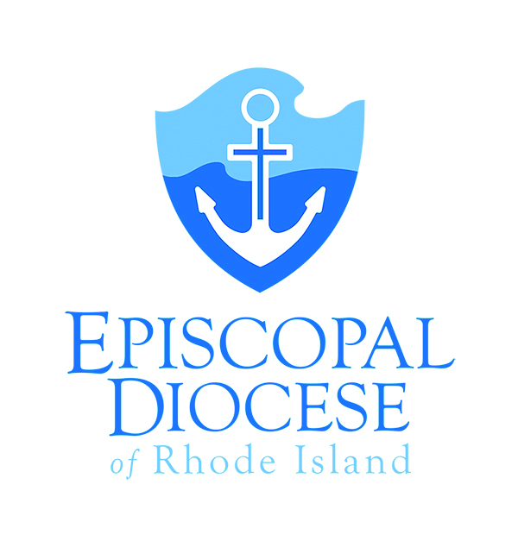
Episcopal Diocese of Rhode Island
Application for Licensing

Request for Licensing as:
_____ Eucharistic Minister _____ Lay Preacher

_____ Eucharistic Visitor _____ Worship Leader

Definitions and requirements for training for licensing can be found on the Licensed Lay Ministries page on the Diocesan Website.
Name: (Please print) __________________________________________
Address: ___________________________________________________
Phone: ________________________
E-mail: _______________________________
CHURCH HISTORY: (please print)
Baptism: __________________________________________________________
Church/City/State/Date
Confirmation: _______________________________________________________
Church/City/State/Date
Present Church: ______________________________________________________

Please complete and attach the following before submitting this application:
- In person training certificate (none needed for Eucharistic Minister)
- Online safe church training certificate
I understand that a license will be issued only after required training components are completed.
Signature: _________________________________________ Date: __________

Signature of Rector/Vicar: ______________________________ Date: __________

Please return this application to:
Bishop’s Office
Episcopal Diocese of Rhode Island
275 North Main Street, Providence, RI 02903

